ListIT - Final Architectural Plan
Cody Crosby
CST-452 Senior Project II
Grand Canyon University
Instructor: Amit Karmaker
Revision: v2.0
Date: September 13th, 2026

ABSTRACT

The purpose of this project is to design and develop a web-based inventory management system capable of organizing and tracking multiple inventory lists through a centralized application. The system will allow authenticated users to create and manage inventory collections, organize items into categories, and perform standard CRUD operations on inventory records. Additionally, the application will include an administrative section for managing users, permissions, and system-level functions.

Many small businesses, hobbyists, and individuals rely on spreadsheets or manual methods to manage inventory, which can lead to disorganization, data inconsistency, and inefficient tracking processes. This project addresses those challenges by providing a structured and scalable inventory solution that improves organization and usability. The system will be developed using modern technology and practices, intended to serve as the intended functional application, as well as a demonstration of full-stack software development skills.

History and Signoff Sheet
Change Record
Date | Author | Revision Notes
7/19/2026 | Cody Crosby | Initial draft for review/discussion
9/11/2026 | Cody Crosby | Revised for improvements/enhancements made during CST-452

Overall Instructor Feedback/Comments

Overall Instructor Feedback/Comments
Integrated Instructor Feedback into Project Documentation
☒ Yes ☐ No

TABLE OF CONTENTS
Design Overview 4
Detailed High-Level Solution Design 5
Detailed Technical Design 8
Appendix A – Technical Issue and Risk Log 29

Design Introduction
The proposed solution for ListIT is a web-based inventory management application designed to provide users with a centralized platform for organizing and maintaining multiple inventory catalogs. The application follows layered MVC architecture, separating presentation, business logic, and data access into distinct components. Users interact with the system through a responsive web interface where they can register accounts, securely authenticate, create inventory catalogs, organize products using categories, and perform standard CRUD operations. Administrative users are provided with an additional dashboard for managing user accounts and system level functions.

The high-level design focuses on usability and modularity. The presentation layer is implemented using Thymeleaf templates, while Spring Boot controllers process user requests and delegate application logic to the appropriate service class. Data is persisted in a MySQL relational database through Spring Data JDBC repositories. Spring Security is used to provide authentication and role-based authorization. A custom logging component is also incorporated into the application to record system events and relevant errors to an external CSV file, providing persistent source of information for debugging and troubleshooting.

Supporting design artifacts are provided to illustrate the proposed solution before implementation begins. User interface wireframes define the layout and navigation of each major application screen, including login, registration, inventory dashboard, catalog management, category management, product management, user profile, and administrative dashboard. UML class diagrams are also included as visual representation of system objects, their attributes, and the relationships between classes.
Deliverable Acceptance Log
ID | Deliverable Description | Comments | Evaluator (internal or external as applicable) | Status | Date of Decision
1 | Data Dictionary | Define database tables, fields, data types, keys, and relationships | Cody Crosby | Completed | 8/19/2026
2 | DDL Script | SQL script used to create the database schema | Cody Crosby | Completed | 8/21/2026
3 | UML | Visual class diagram for entities, services, and architecture | Cody Crosby | Completed | 8/19/2026
4
5

Detailed High-Level Solution Design
The system is organized into distinct layers that promote separation of concerns, making the application easier to maintain, extend, and test. User requests are received through the presentation layer, processed by the controller classes, validated and executed within the service layer, and ultimately persisted to the relational database through Spring Data JDBC repos. Entity and model classes represent the app data, while mapper classes facilitate data transfer between the persistence and presentation layers.
Configuration of the solution includes the Spring Boot application, MySQL database, Spring Security, and HTTPS communication. User authentication and role-based authorization restricts access to protected areas, with input validation and password encryption helping to maintain application security and data integrity. A custom logger records events and error so an external CSV file, providing persistent logging that may be used for later debugging. Together with the supporting design artifacts, including the layered architecture diagram, UML diagrams, ER diagram, workflow diagrams, wireframes, and data dictionary, this documentation should provide sufficient details for another developer to understand and implement the design.

Proof of Concepts
Description | Rationale | Results
No proof-of-concept prototypes were needed due to the maturity and stability of the selected technologies | No proof-of-concept implementations were required. The selected technologies, Spring Boot, Spring Data JDBC, MySQL, Thymeleaf, and Spring Security, are established technologies that are already successfully used. | N/A

Hardware and Software Technologies
1 – Spring Boot: Primary application framework providing MVC architecture and dependency management
2 – Spring Data JDBC: Data access framework used to communicate with the MySQL database
3 – MySQL Server: Relational database management system
4 – Thymeleaf, bootstrap, HTML5, CSS3, JavaScript: User interface technologies used to develop responsive frontend
5 -STS4, Java 17, Spring Security: Development IDE, programming language, and application security

Hardware Requirements
Requirement | Recommended | Purpose
Processor | Dual-core processor of better | Supports application development and local execution
Memory | 4 GB minimum; 8 GB recommended | Supports Java, Spring Boot, MySQL, IDE, and browser operation
Storage | 5 GB available | Application files, database, source code, and log files
Network | Local network or internet connection | Required for web-based application access and development dependencies

Software Requirements
Requirement | Recommended | Purpose
Operating System | Windows 10/11 or similar OS | Host operating environment
Java | JDK 17 | Application development and execution
Spring Boot | 3.4.4 | Primary application framework
MySQL Server | 8.0.44 | Relation database management
Web Browser | Current Chrome, Edge, Firefox, or equivalent | Access to the ListIt web interface
Spring Tool Suite 4 | STS4 or compatible Java IDE | Application development and debugging
MySQL Workbench | 8.0.44 | Database design and administration

Logical Solution Design:
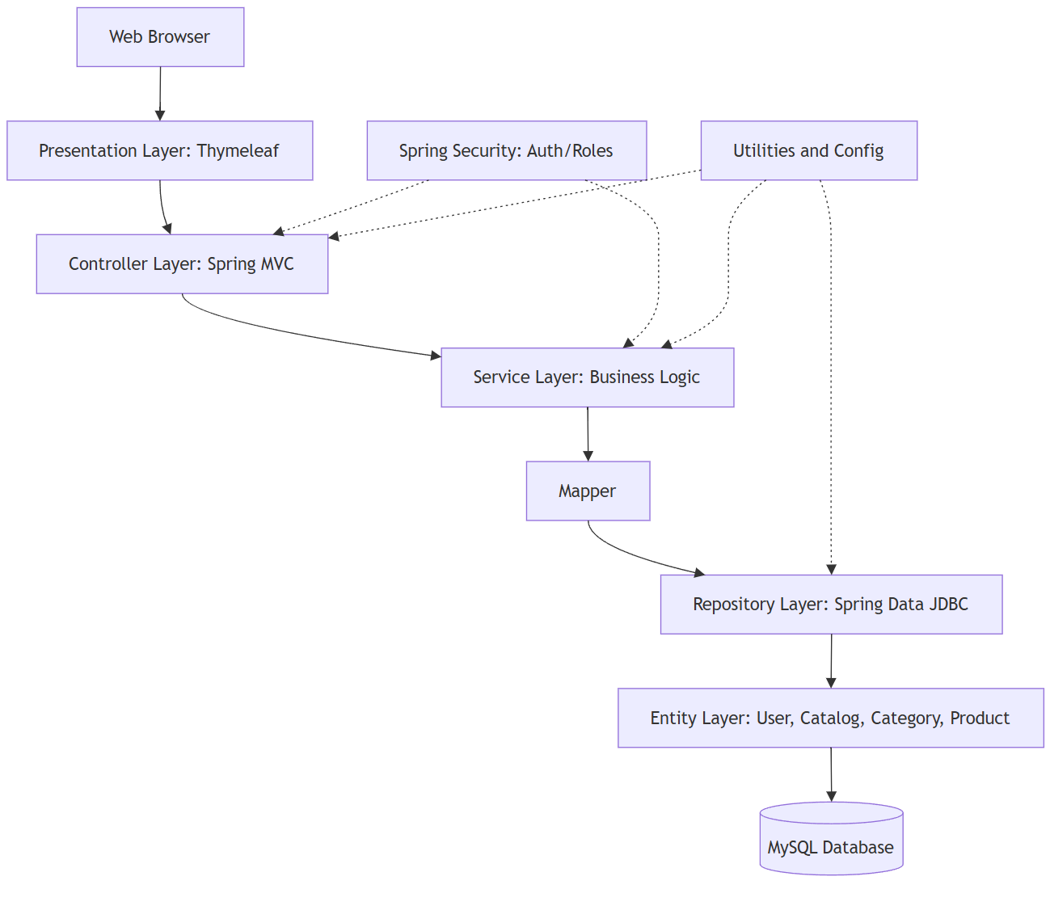
Figure 1: Layered Architecture Diagram

The logical solution design is represented by the Layered MVC Architecture Diagram (figure 1), which illustrates the flow of information between the presentation layer, controllers, services, repos, mapper classes, entities, models, and the relational database. Additional supporting design artifacts, including the ER diagram, DDL script, UML class diagrams, workflow diagrams, and UI Wireframes, are included in their respective sections in the document and define the logical organization of the system.

Physical Solution Design:
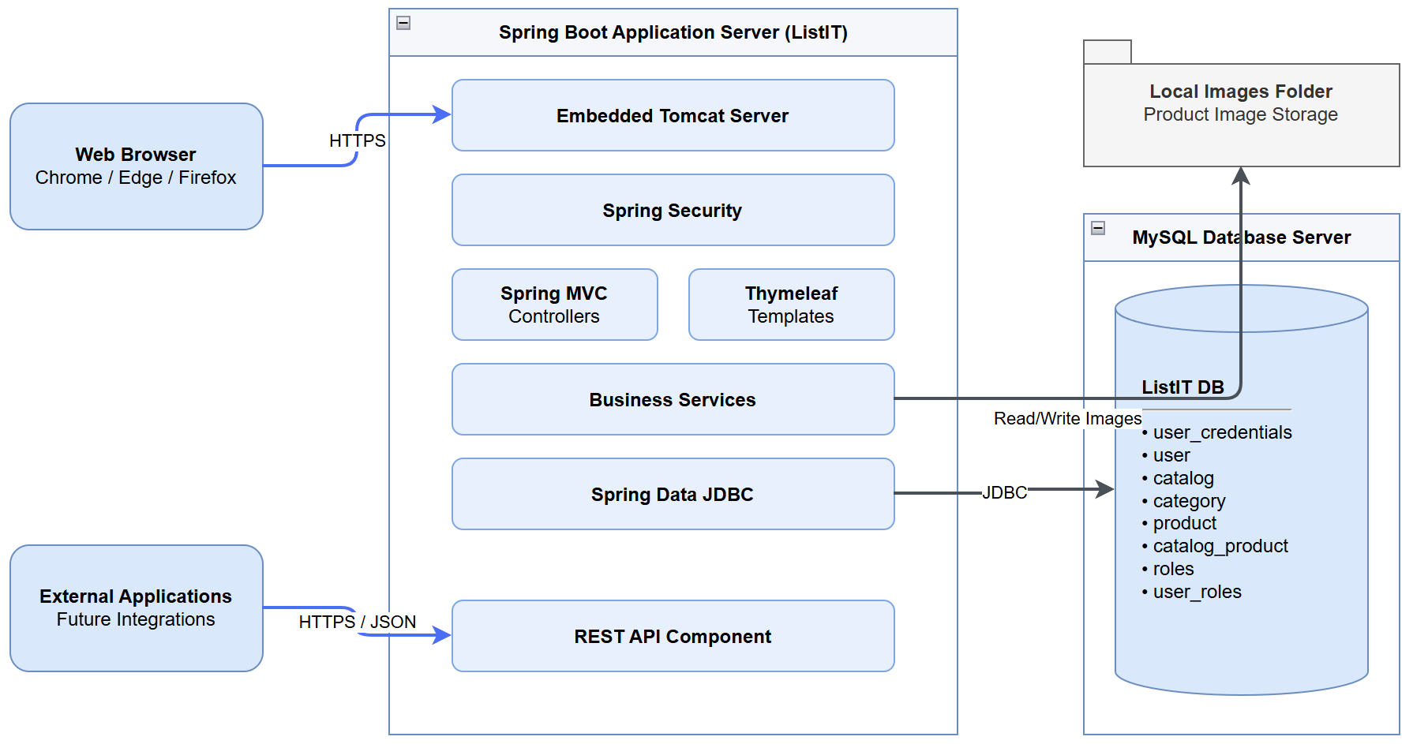
Figure 2: Physical Solution Design Diagram

The physical solution consists of a client web browser communicating with the Spring Boot app over HTTPS. The application executes the business logic and accesses the MySQL database through Spring Data JDBC. During development, all components are hosted locally on the workstation during development. The architecture can later be deployed to a production server with minimal configuration changes. The application also includes a custom logger that writes system events and errors to an external CSV file.
Detailed Technical Design
General Technical Approach:
ListIT was designed, and will be developed, using an iterative approach, with implementation following the completion of project requirements and architectural designs. The system is designed to follow the MVC architectural pattern to promote separation of concerns and maintenance. Core functionality will be implemented first, beginning with user authentication and authorization, then moving onto catalog management, category management, and product management, followed by administrative functionality and additional enhancements as time permits. Project planning and architecture were refined through requirements gathering, user stories, database design, UI wireframes, UML diagrams, and process flow diagrams. These artifacts provide the roadmap for implementation and ensure the application details are well defined before development begins. Development will be incremental, with testing carried out continuously as each feature is completed.

Key Technical Design Decisions:
Key Technical Design Decisions
Technology/Framework | Purpose | Rational
Spring Boot | Primary application framework | Provides an enterprise-level framework with integrated support for dependency injection (DI), MVC architecture, and rapid application development (RAD)
Spring Data JDBC | Database Access Layer | Simplifies database interactions while maintaining explicit SQL mapping and a lightweight persistence model
Spring Security | Authentication and authorization | Provides secure user authentication, password encryption, and role-based access control using established practices
Thymeleaf | Server-side view rendering | Integrates with Spring Boot while enabling dynamic HTML page generation and simplified MVC implementation
MySQL | Relational database management | Provides a reliable relational database platform capable of supporting normalized data structures
Spring Tool Suite 4 (STS4) | Integrated Development Environment (IDE) | Offers native support for Spring Boot development, debugging, dependency management, and project configuration
MySQL Workbench | Database modeling and administration | Used to design the database schema, generate DDL scripts, and manage the relational database during development
Bootstrap | User Interface framework | Provides responsive layouts and reusable UI components to create a consistent user experience across different pages
HTTPS | Secure communication | Protects data transmitted between the client and server through encrypted communications
Custom Logger | System event and error logging | Records system events and errors in an external CSV file to provide persistent logging for debugging and troubleshooting

Database ER Diagram:
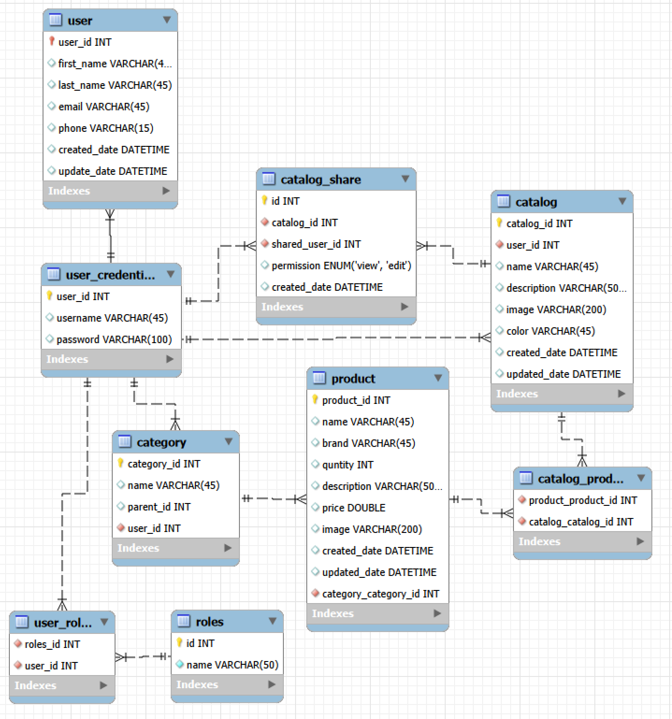
Figure 3: ListIT's Database Diagram
ER diagram showing database tables, their columns, and the respective relationships.

Database DDL Scripts:
The DDL script and Data Dictionary are externally linked below:
DDL: ListITDatabase.sql
Data Dictionary: CST-451DataDictionary.xlsx

Flow Charts/Process Flows:
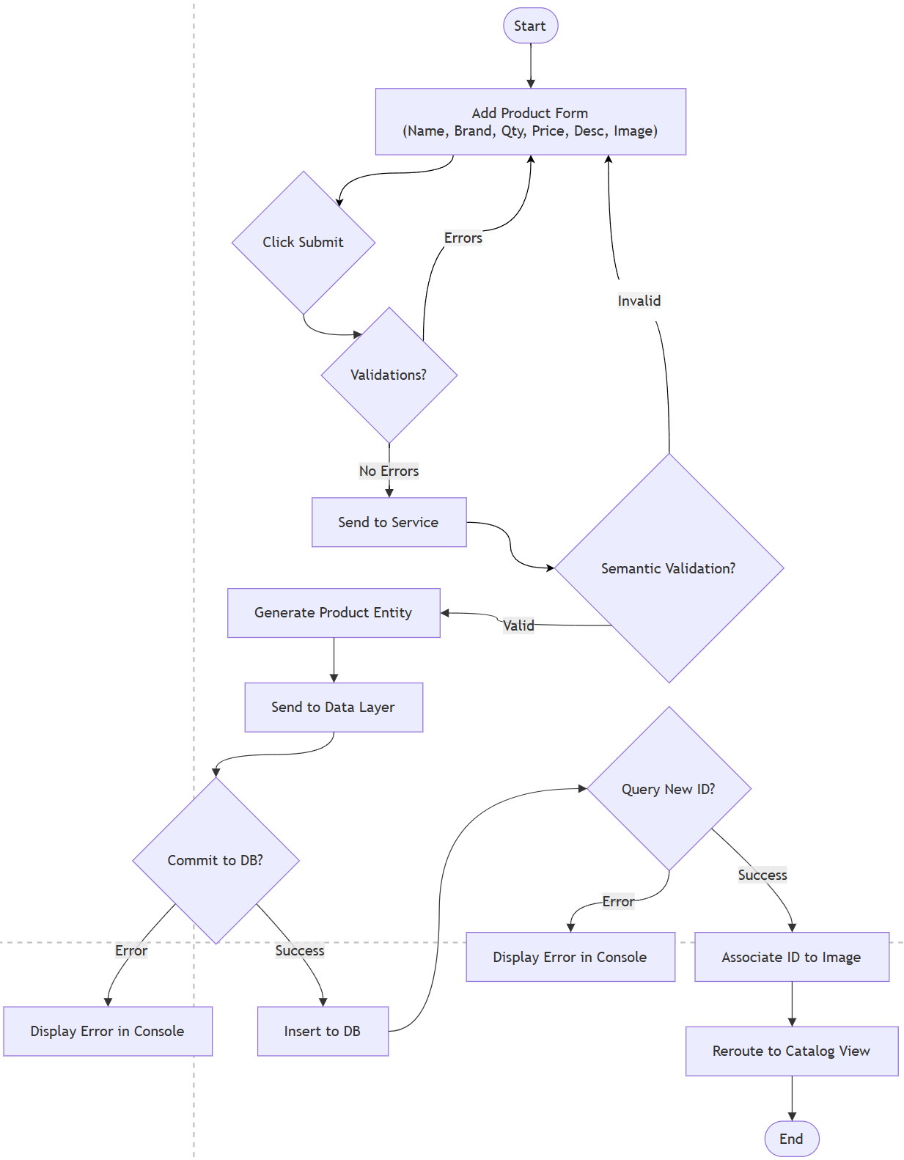
Figure 4: Flowchart - Add Product Workflow
Flowchart demonstrating the Add Product workflow, including error handling scenarios.

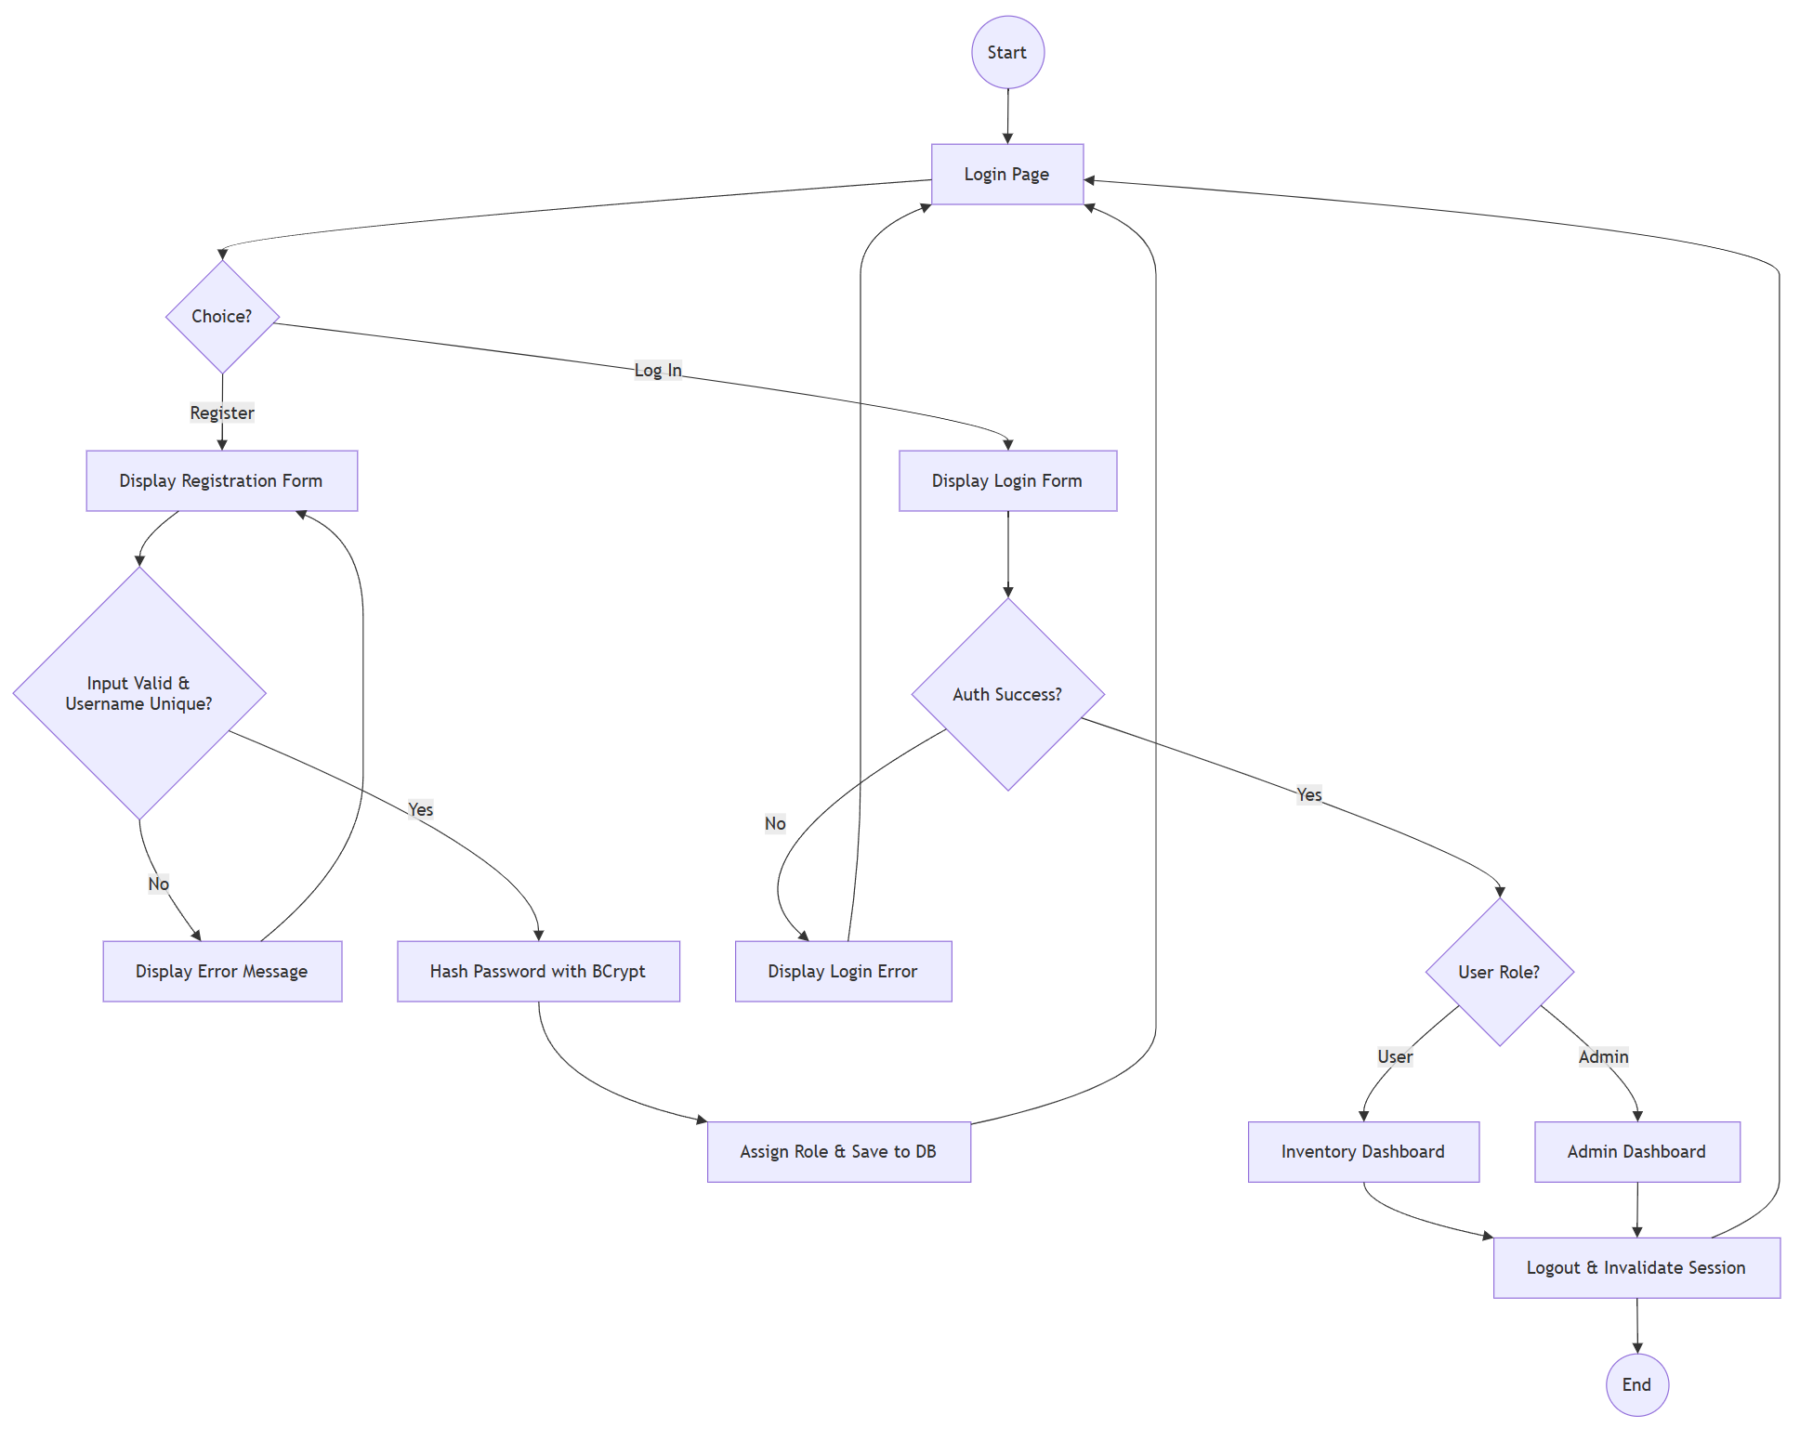
Figure 5: Flowchart - User Registration and Login Workflow
Flowchart demonstrating the registration and login workflow, including error handling

Sitemap Diagram:
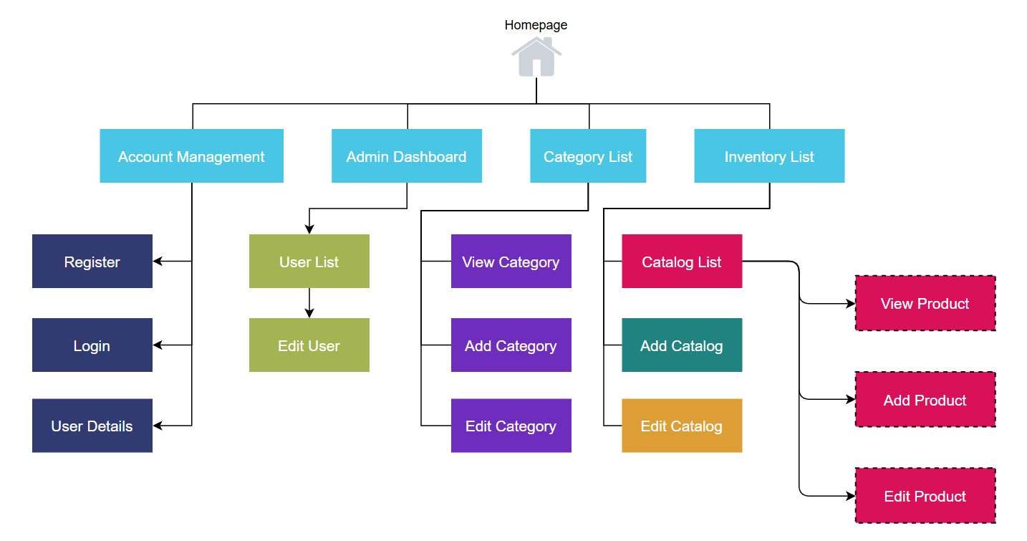
Figure 6: Sitemap Diagram - ListIT
Sitemap diagram depicting the overall structure of the ListIT application. Includes branches for account management, administrative functions, category management, and inventory management.

User Interface Diagrams:
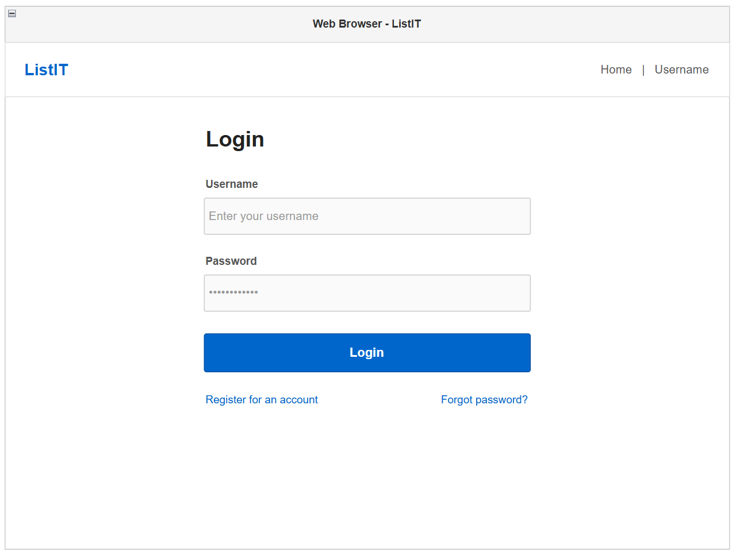
Figure 7: Wireframe - Login Page
Login page for registered users to login with valid username and password.
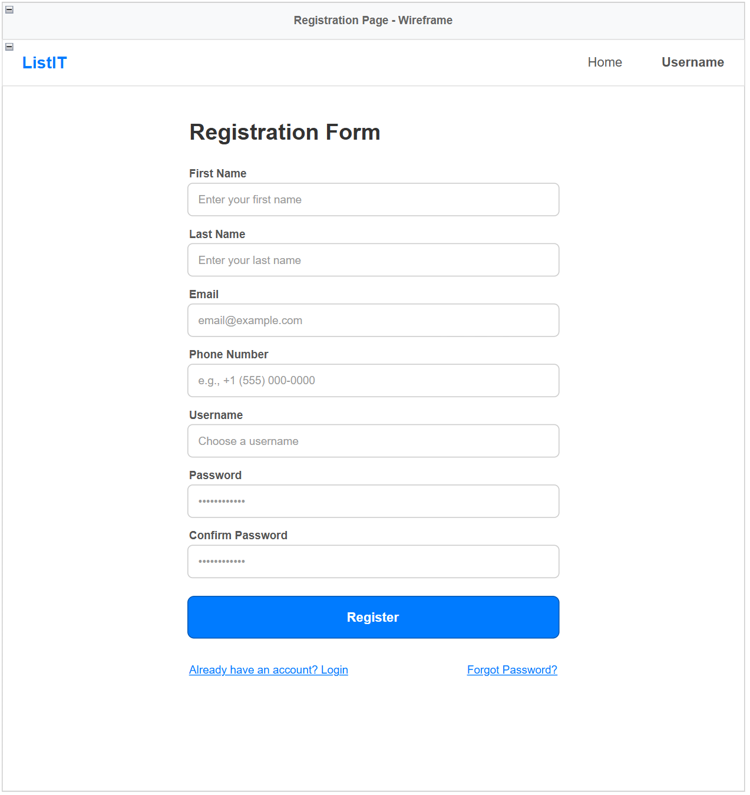
Figure 8: Wireframe - Registration Form
Allow new users to create an account with personal information and valid login credentials.
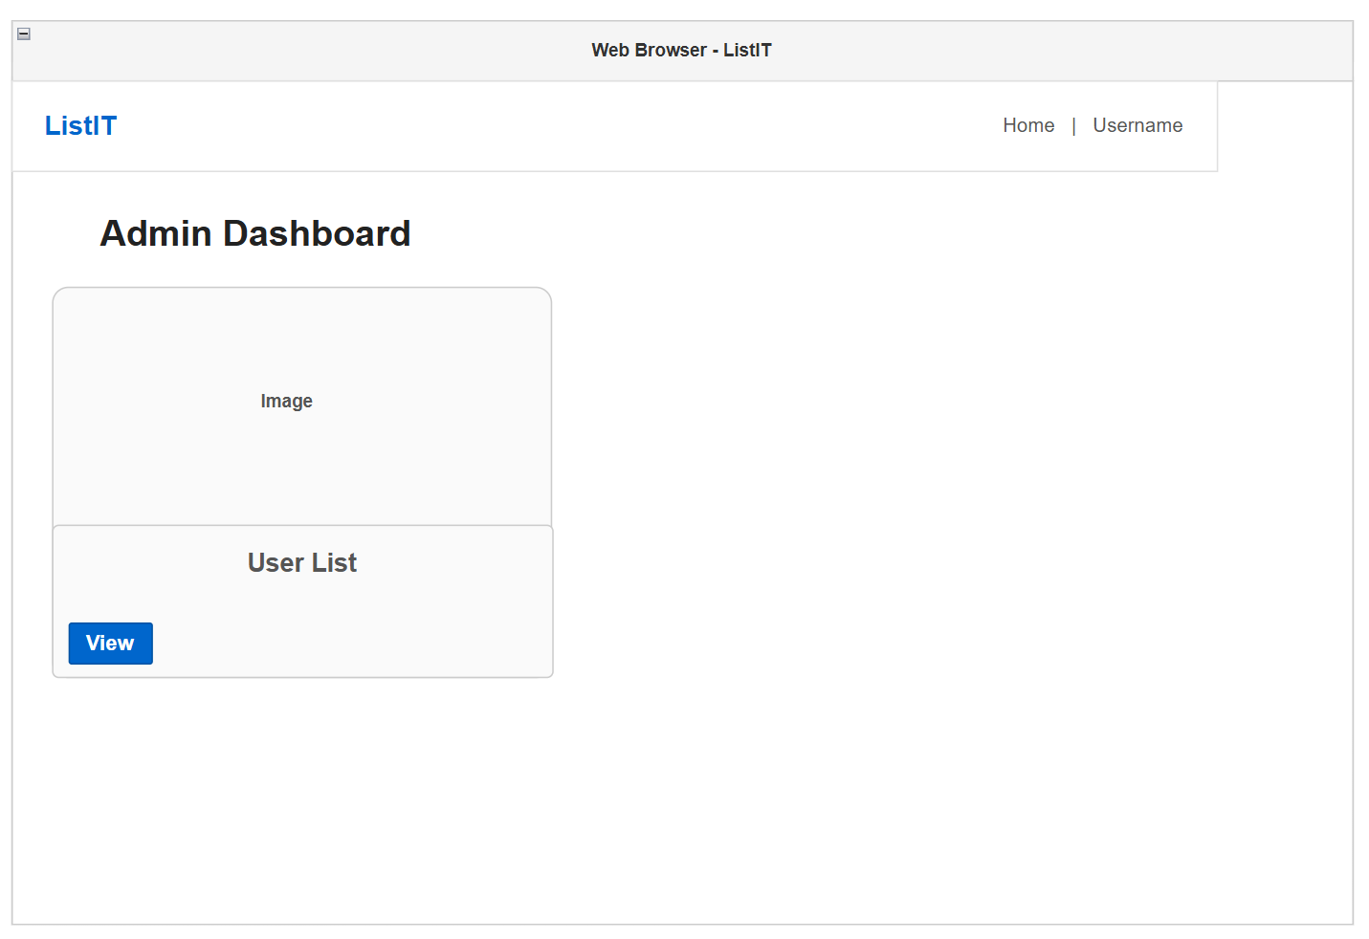
Figure 9: Wireframe - Admin Dashboard
Provides administrators with access to system management functions.
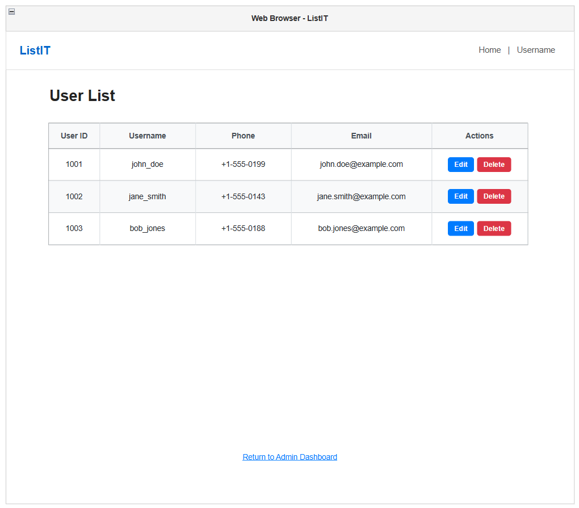
Figure 10: Wireframe - User List Page
Display all registered users in a table format.
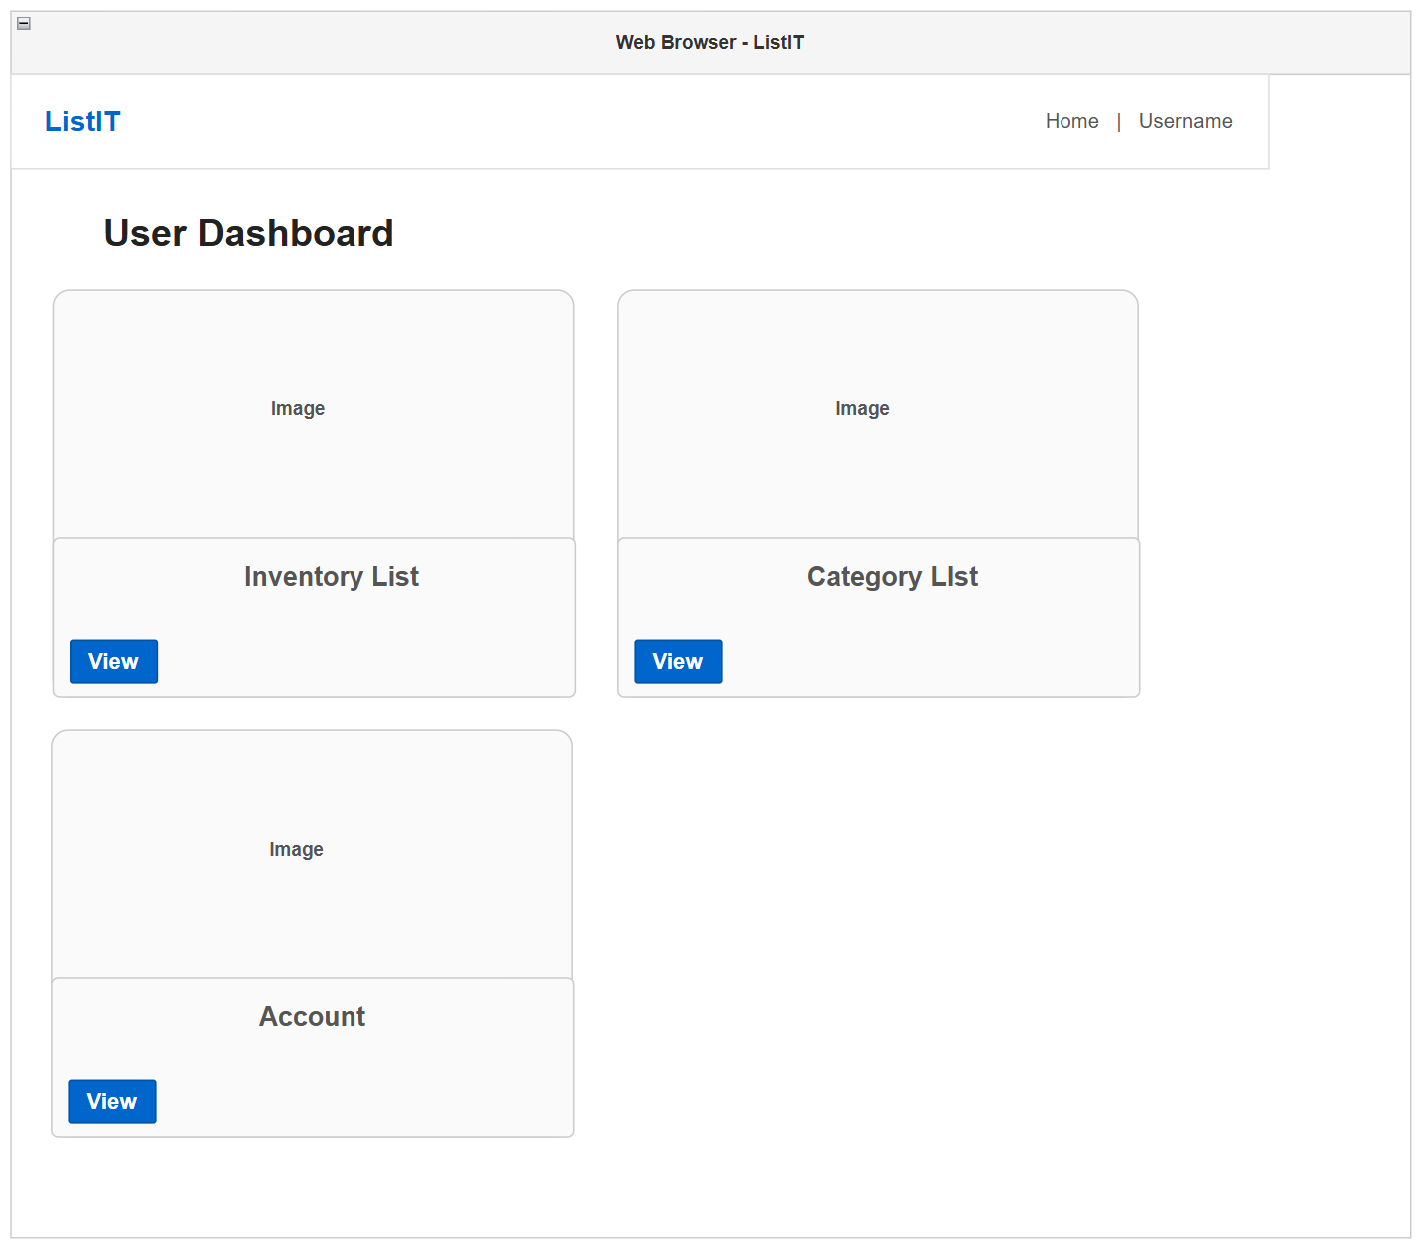
Figure 11: Wireframe - User Dashboard
Serves as the primary navigation page for authenticated users.
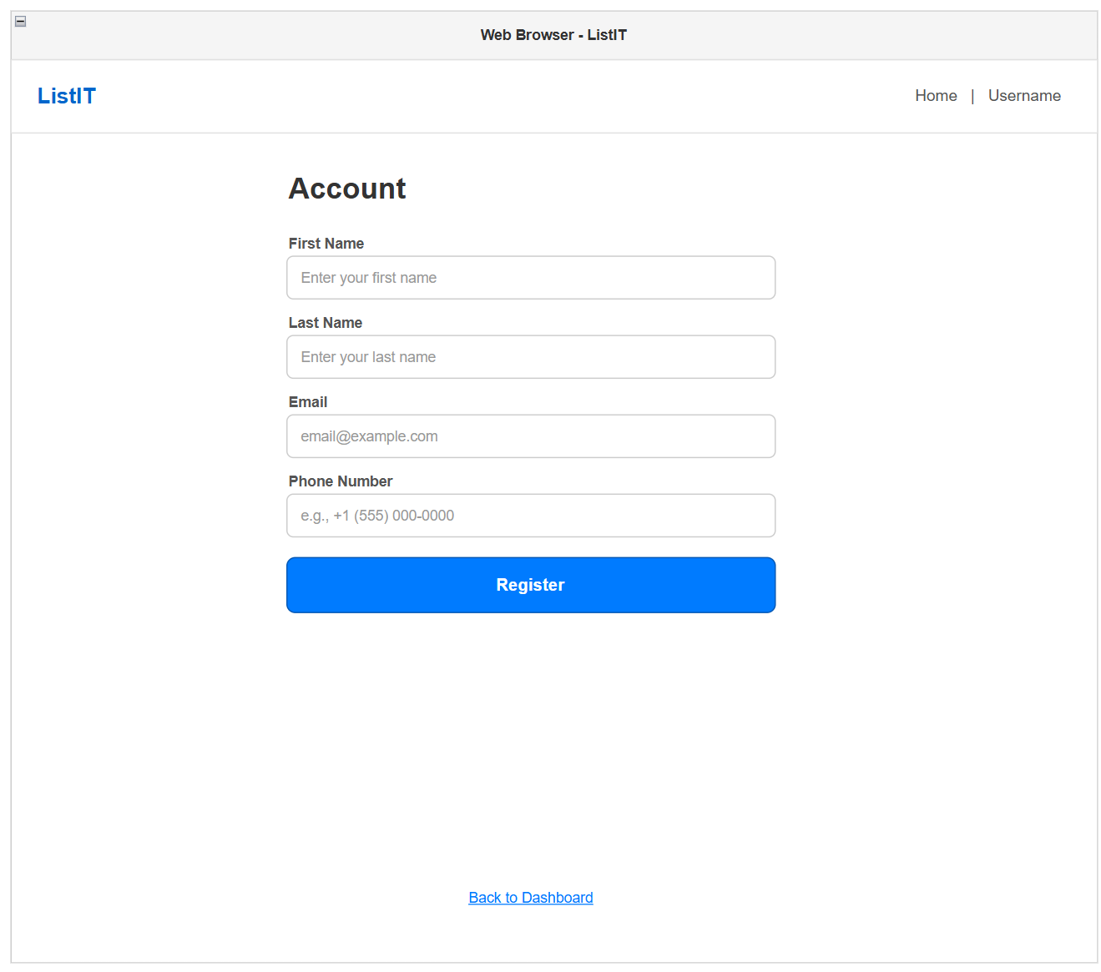
Figure 12: Wireframe - Edit User Details Form
Allow users to view and update their personal account information with updates being persisted to the database.
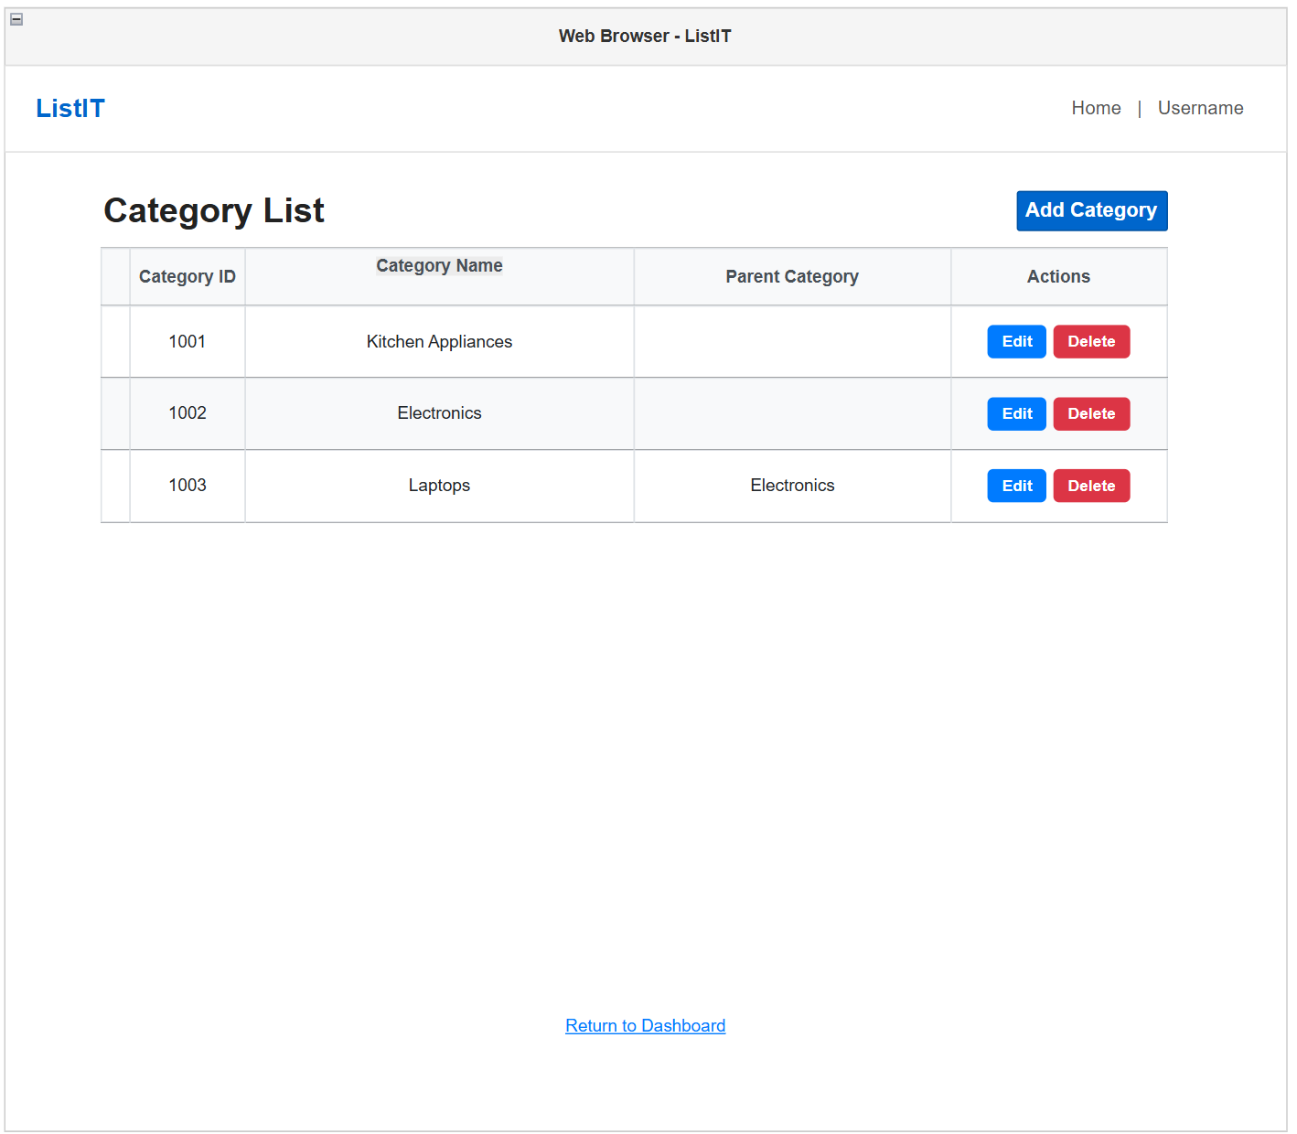
Figure 13: Wireframe - Category List Page
Displays the user’s categories in a table with options to edit and delete existing entries with a button to add new categories.
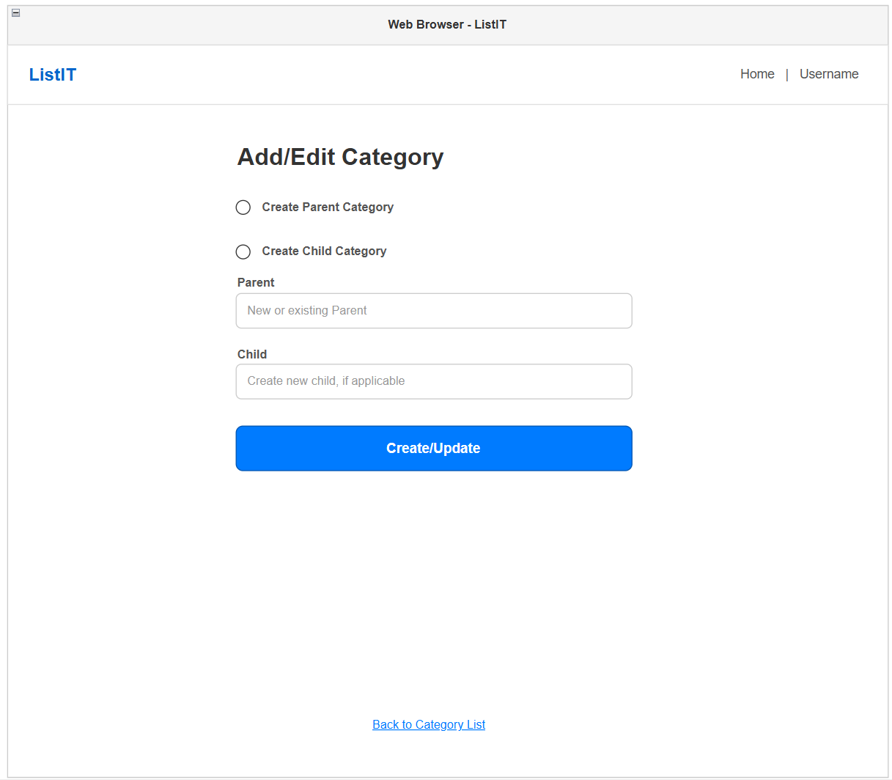
Figure 14: Wireframe - Create/Edit Category Form
Allows user to create or modify parent and child categories.
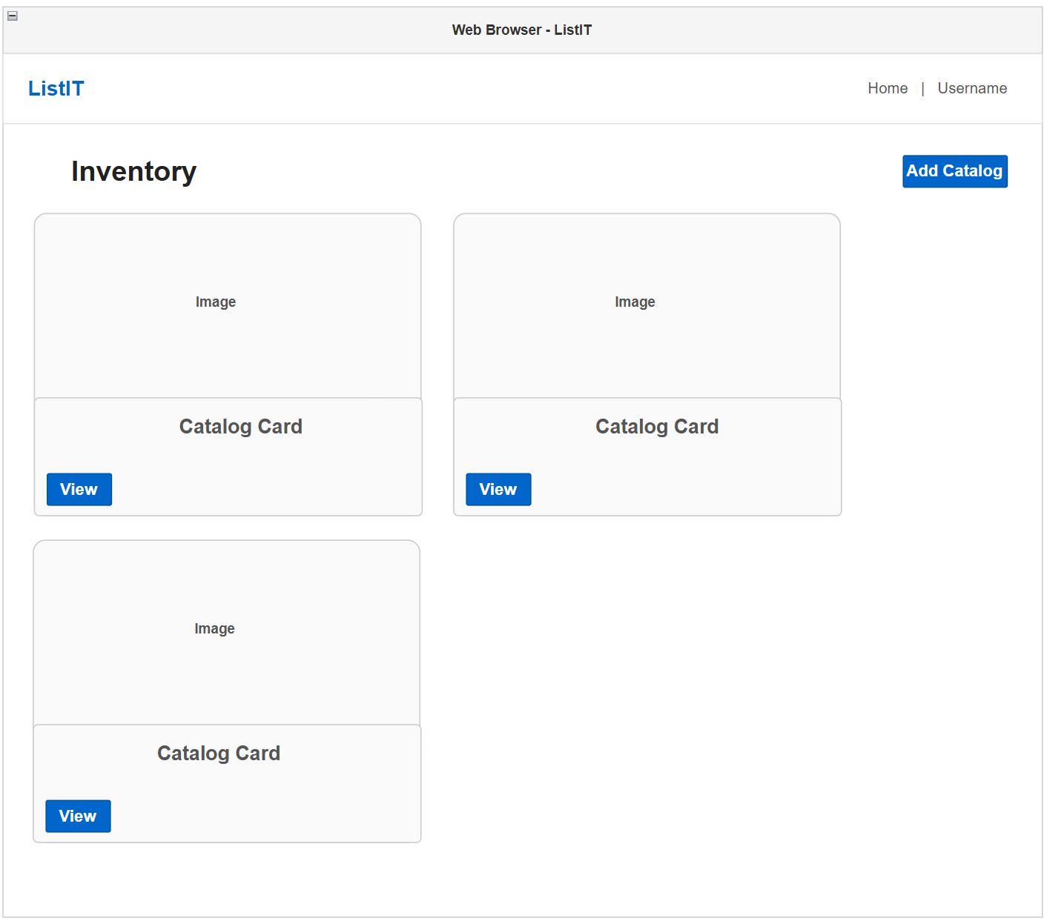
Figure 15: Wireframe - Inventory List Page
Displays the user’s inventory catalog cards containing images and summary information.
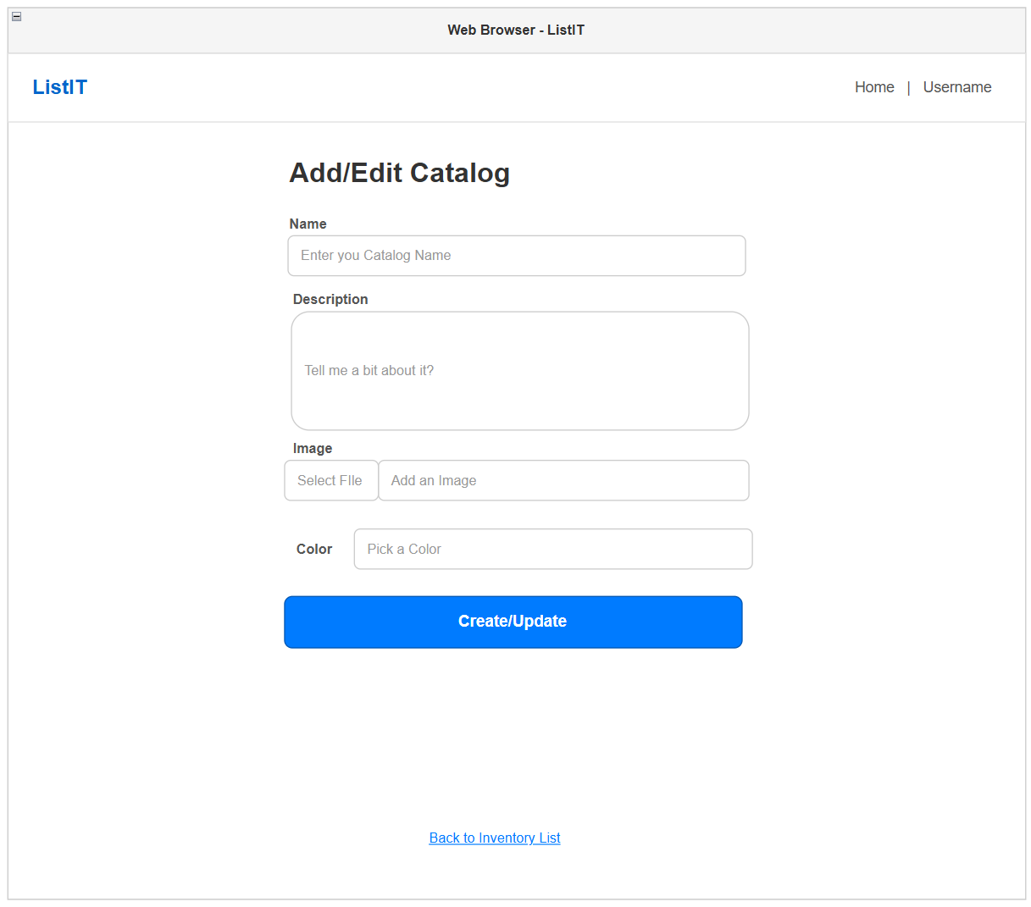
Figure 16: Wireframe - Create/Edit Catalog Form
Allow users to create new catalogs or modify details of existing catalogs.
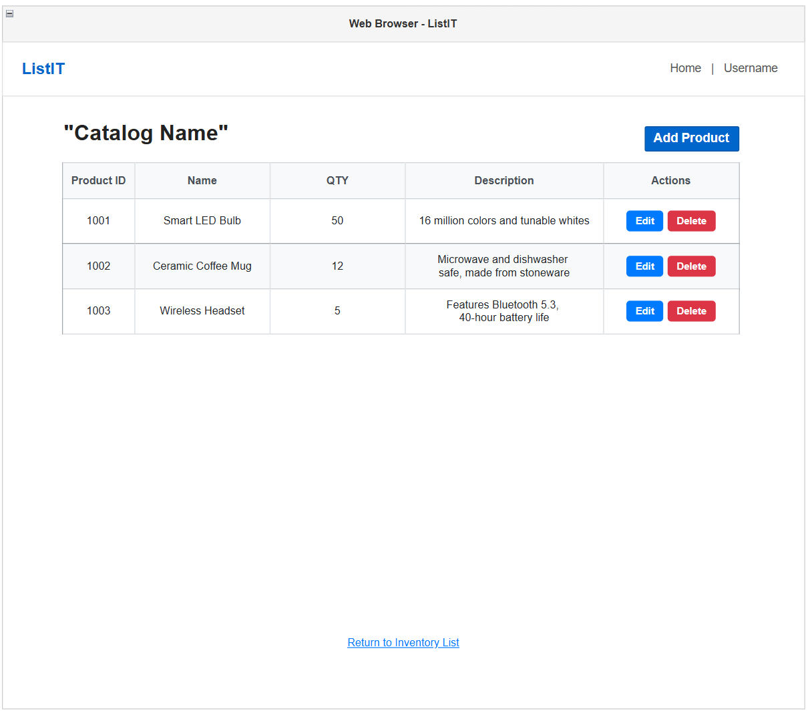
Figure 17: Wireframe - Catalog View Page
Displays all products contained within a selected catalog.
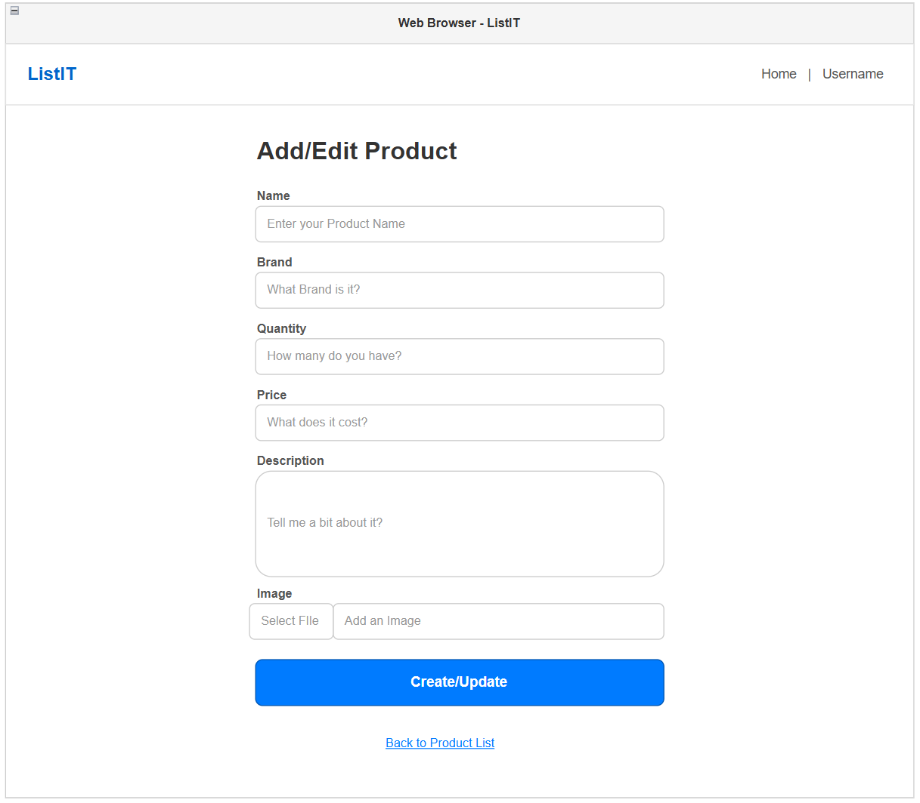
Figure 18: Wireframe - Create/Edit Product Form
Allows users to create or update product information including quantity, pricing, description, and images.

UML Diagrams:
Full UML Diagram is externally linked below:
UML: UML.png

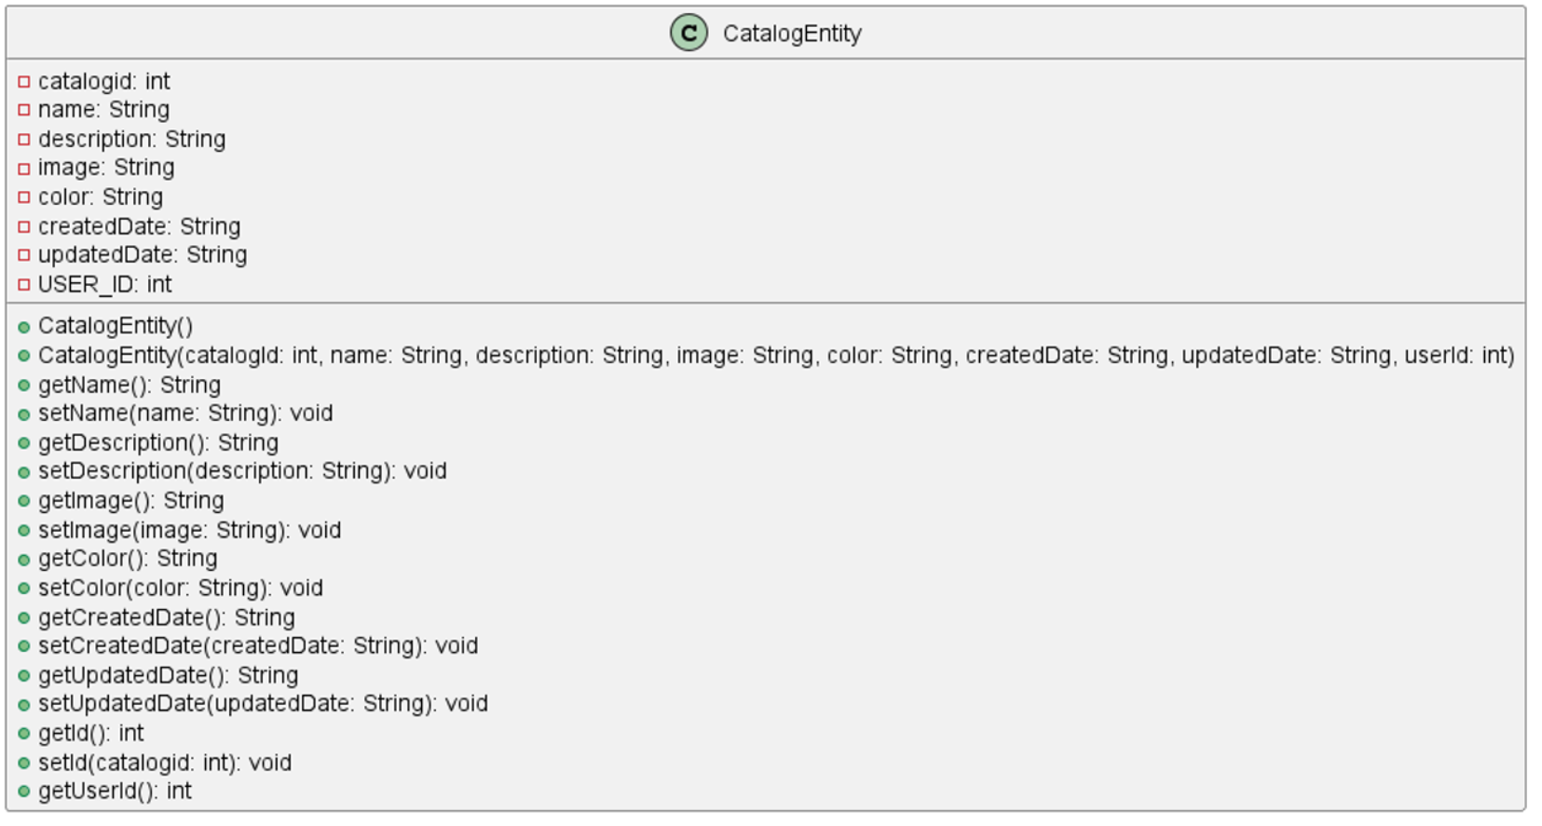
Figure 19: UML - Catalog Entity
CatalogEntity representing Catalog objects including id, name, description, and other details

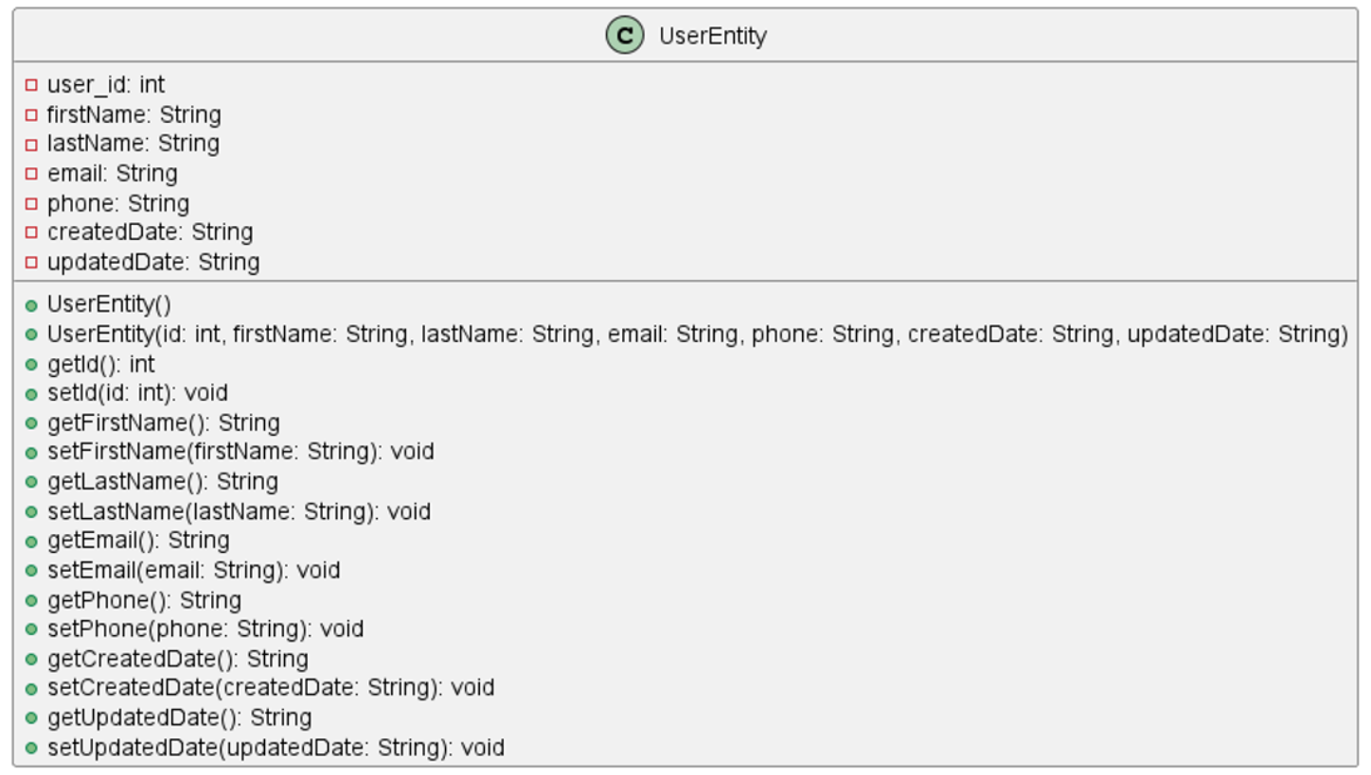
Figure 20: UML - User Entity
UserEntity representing user details, excluding credentials
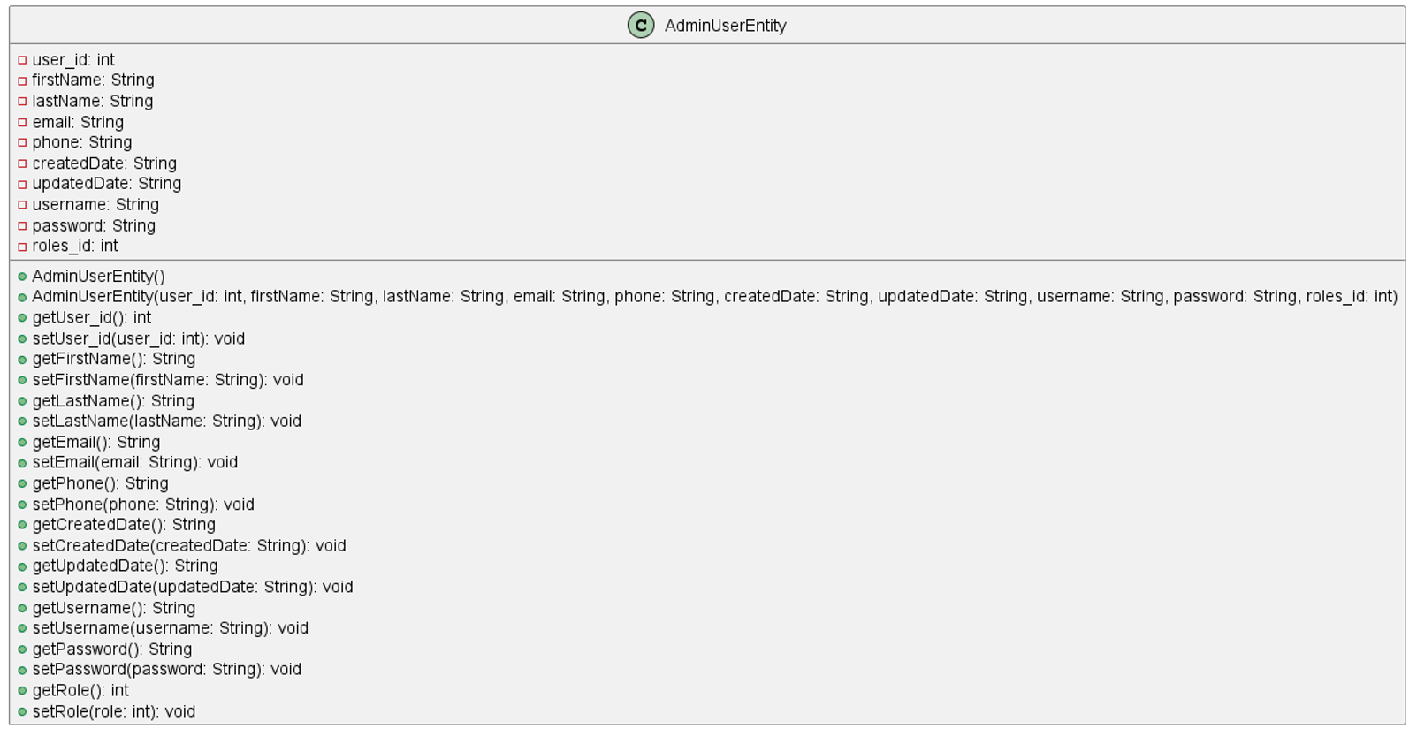
Figure 21: UML - Admin User Entity
AdminUserEntity for operations requiring all user details

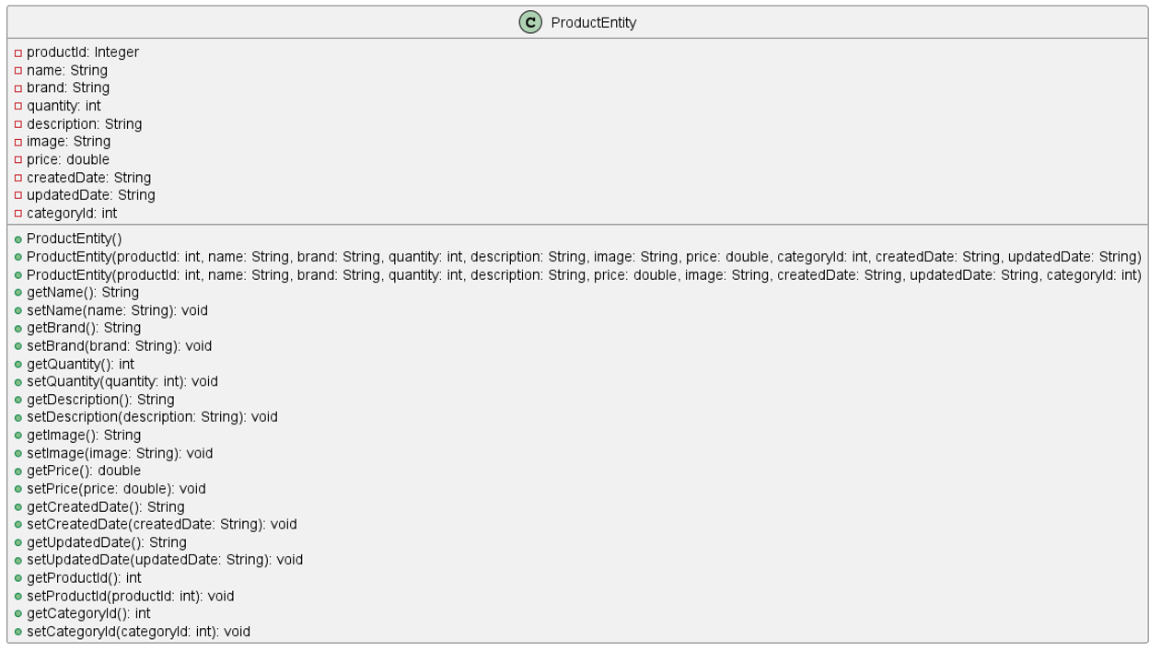
Figure 22: UML - Product Entity
ProductEntity to represent individual project items, including users visible fields and metadata
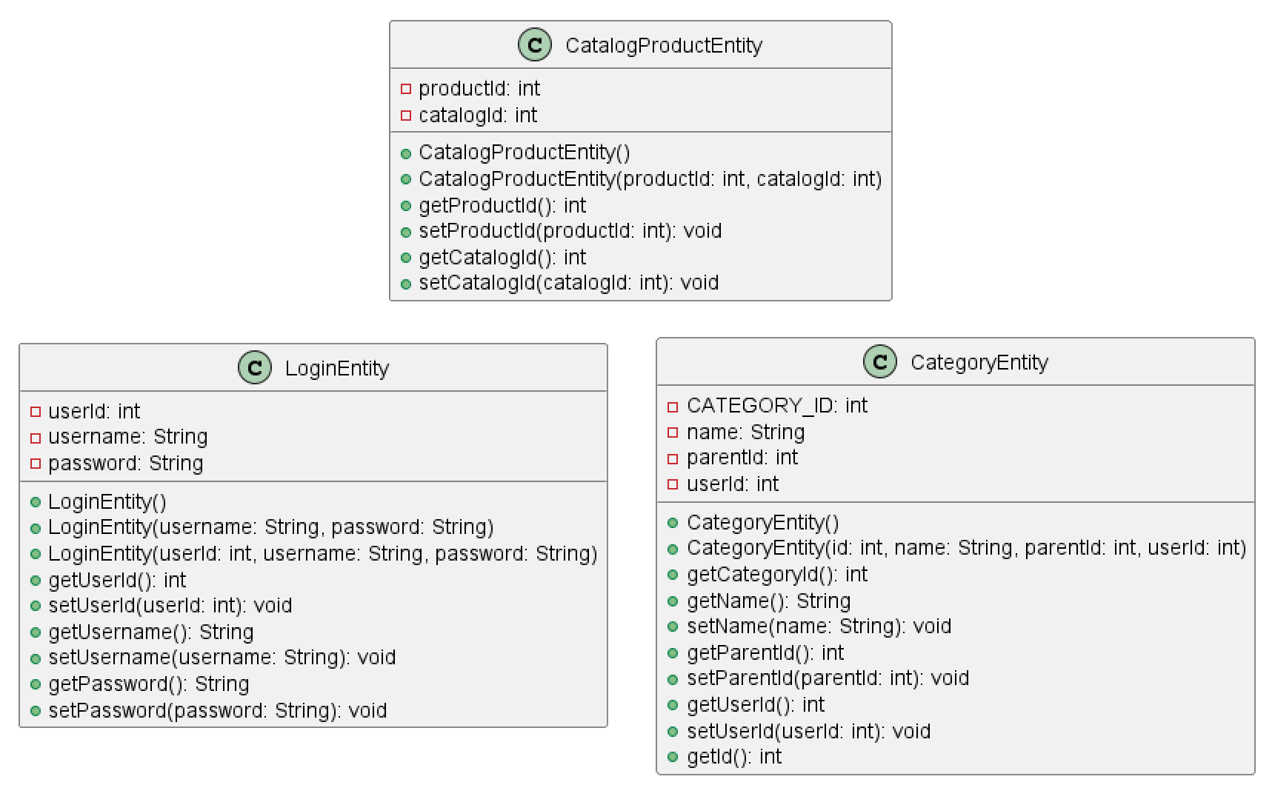
Figure 23: UML - Catalog Product, Category & Login Entities
Other Entities used for supporting functions throughout the app

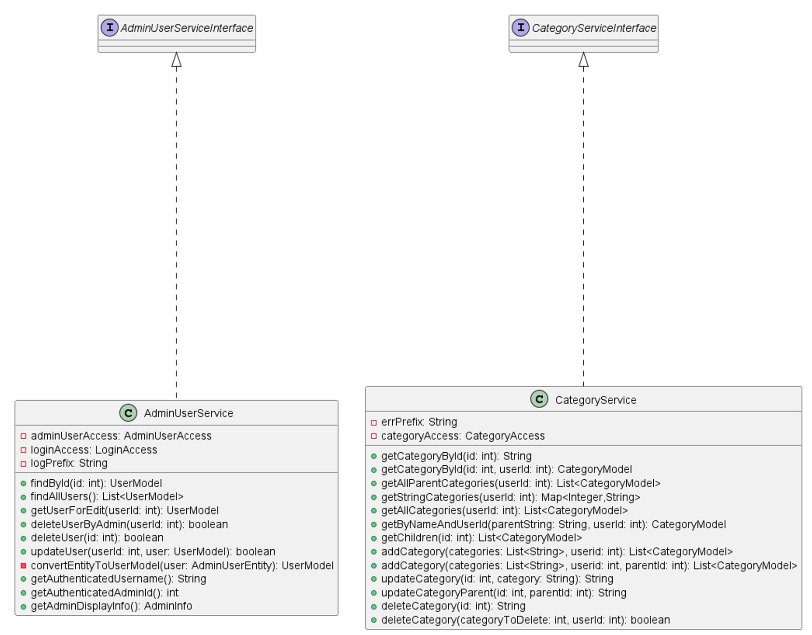
Figure 24: UML - Admin User and Category Service Classes
Service classes and their respective interfaces, used for modifying Users and managing Categories
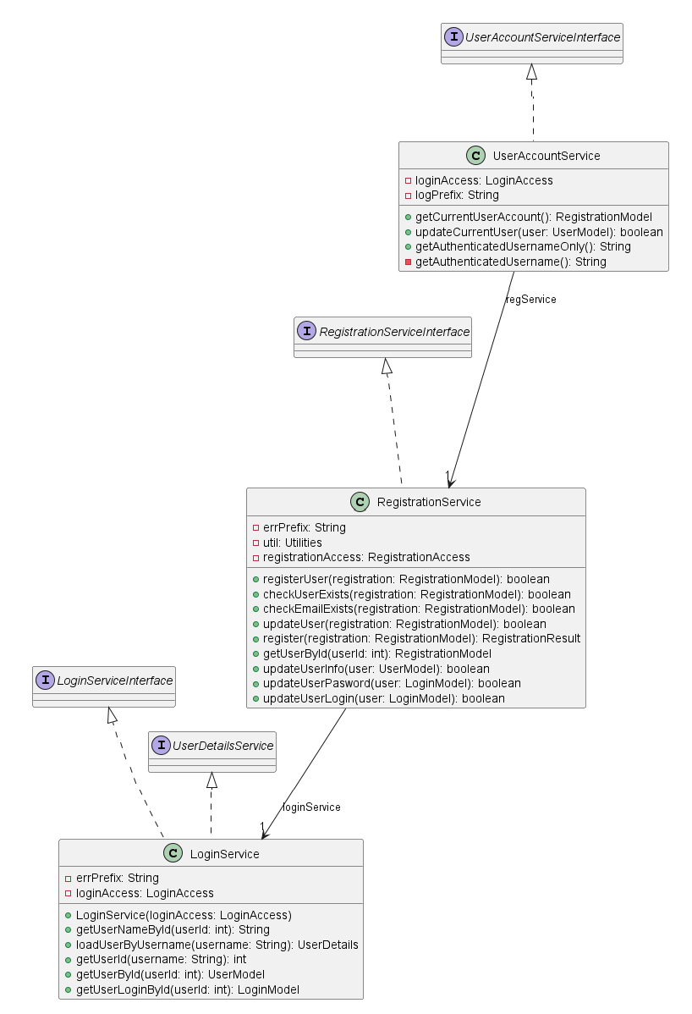
Figure 25: UML - Login, Registration & UserAccount Service Classes/Relationship
Service and interface relationships for the login and registration workflows

Service API Design:
ListIT does not consume any third party APIs and does not currently publish a public REST API. The application is designed with a layered architecture that would allow REST endpoints to be added in future revisions without significant structural changes

NFR’s (Security Design, etc.):
Functional and Non-Functional Requirements are linked below:
FR/NFR: UserStoriesAndNonFunctionalRequirements.xls

The design incorporates several architectural decisions to satisfy the project’s NFR’s. Security is provided through Spring Security using authentication and role-based authorization to restrict access to protected resources. User passwords are salted and encrypted using BCrypt before being stored in the database, and all client-server communication occurs over https to protect data in transit. Performance and maintainability are achieved through the MVC architecture. Spring Data JDBC provides efficient interactions with the MySQL database, while normalized database design and foreign key constraints help maintain data integrity. User input is validated before processing to reduce invalid or inconsistent data.

Operational Support Design:
Operational support is provided through application logging and exception handling during development and testing. The application uses a custom logger to persist application events, warining, errors, and other relevant information to an external CSV log file. This provides a persistent record of application activities that can be reviewed for debugging and identifying issues after they occur. Standard Spring Boot messages will still be displayed in the console, but application-specific log are persisted to the external file for ongoing support.

Other Documentation:
N/A. The supporting documentation for the project has been incorporated directly into the Final Architectural Plan. All required design artifacts, including UML class diagrams, logical and physical architecture diagrams, entity-relationship diagrams, workflow diagrams, data dictionary, DDL script, UI wireframes, sitemap, Functional and Non-Functional requirements, and project risks have been included within this document.
Appendix A – Technical Issue and Risk Log
- Use the template to identify and monitor project issues and risks.
Issues and Risk Log
Issue or Risk | Description | Project Impact | Action Plan/Resolution | Owner | Importance | Date Entered | Date to Review | Date Resolved
Risk | Limited development time may require lower-priority features to be delayed | May reduce project scope or delay completion of non-essential functionality. No additional project cost is expected | Prioritize core features first and defer optional features as needed | Cody Crosby | High | 6/20 | Weekly
Issue | Refactoring the original codebase to improve architecture | Increased development time early in the project but improves consistency | Refactor incrementally and verify functionality through continuous testing | Cody Crosby | Medium | 6/29 | 7/2 | 7/12
Risk | Security configuration and authentication may require additional testing | Could delay implementation if security issues are discovered | Implement Spring Security using best practices and perform regular testing | Cody Crosby | High | 7/1 | Weekly

